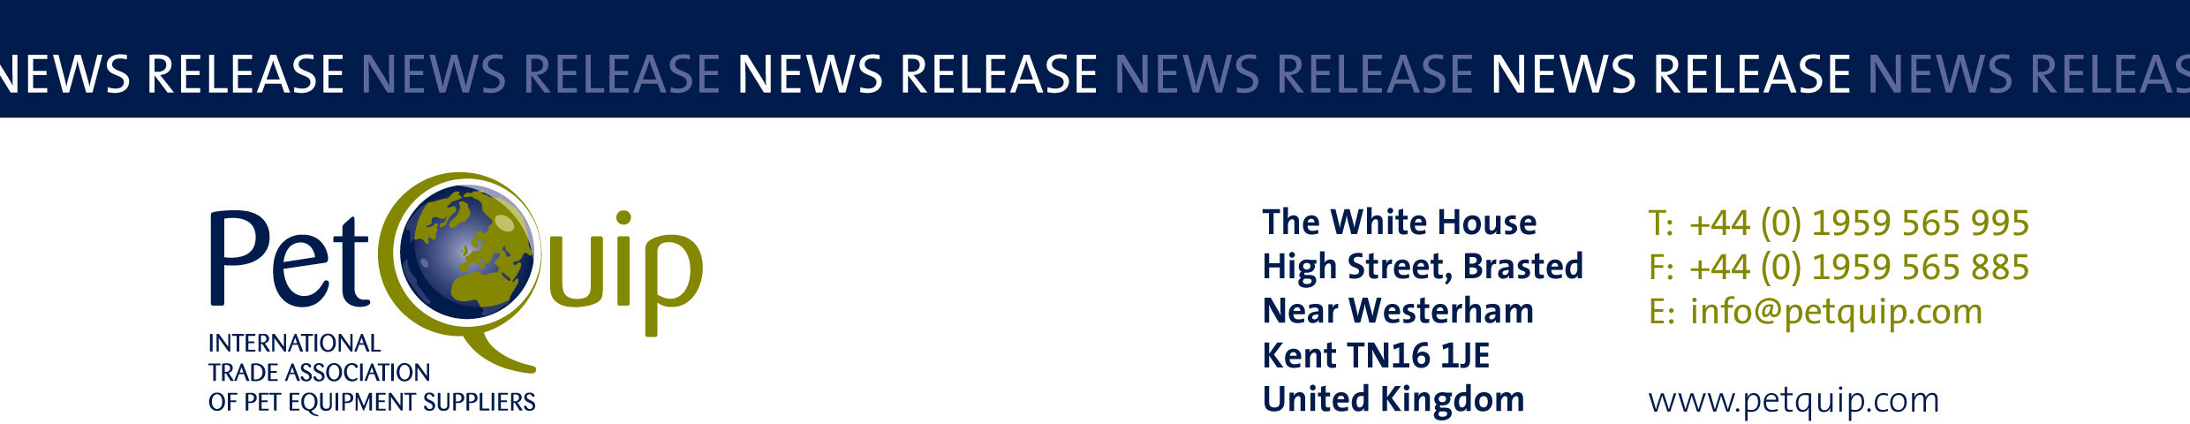

A division of The Federation of Garden and Leisure Manufacturers Limited
Registered in England and Wales No. 706025. Registered Office as above. VAT Registration No. 230906018

FOR IMMEDIATE RELEASE 30 July 2020

PetQuip supports and promotes the British exhibitor group
for the rescheduled Interzoo show on 1-4 June 2021

PetQuip is already planning for the rescheduled Interzoo, which will now take place in Nuremberg, Germany, on 1-4 June 2021.

The international pet trade exhibition was due to take place on 19-22 May this year but the organisers decided to postpone the show because of the coronavirus pandemic.

Now that a new date has been confirmed, those UK companies still intending to exhibit can work on their plans for the show. For eligible SMEs taking part there should be the added advantage of Department for International Trade grants to help offset the cost of a stand. PetQuip has put in a request for grants to be made available for the new show dates and it is hoped that at least £1,000 per eligible exhibitor will be available.

Companies interested in exhibiting at the 2021 show should contact Katie-Mai Smith at katie-mai@petquip.com for further information or visit www.petquip.com for stand details, costs and booking forms.

When the decision to postpone Interzoo was made, PetQuip put together a package of additional publicity and support to ensure PetQuip’s UK group of Interzoo 2020 brands and product introductions were promoted to buyers through key international media.

An HTML UK group brochure for PetQuip’s Interzoo 2020 exhibitors is being compiled and this will be sent out to buyers selected from the association’s exclusive international buyer database in the coming weeks. By carrying out these activities PetQuip will be able to promote exhibitors’ brands and products to a wide range of international buyers who would have been visiting the PetQuip information stand and the UK group at this year’s event.

PetQuip starts the promotion process here by highlighting companies and products that were due to be present at Interzoo on the original show date this year – please see the attached document for details of these companies and their products.

PetQuip is the International Trade Association of Pet Equipment Suppliers. The PetQuip team assists and promotes the development of international trade in the pet equipment sector, providing a catalyst for business contact between manufacturers, suppliers and international buyers around the world. As part of its free UK pet product sourcing service to overseas buyers, PetQuip publishes the PetQuip Buyers’ Guide, which includes a directory of members’ product ranges, and copies are available to all buyers on request.

PetQuip is also holding a series of virtual Meet the International Buyer events, bringing buyers and suppliers together to create new business opportunities for both via video conference calls. Please contact katie-mai@petquip.com if you are a buyer or distributor who would like to meet with innovative UK pet product and accessory suppliers.

Please contact PetQuip if you would like to benefit from membership of the association or require any further advice and assistance:
Email: info@petquip.com
Website: www.petquip.com

For further press information contact:
Neil Pope
PetQuip PR Consultant
Tel: 07595 442601
Email: press@petquip.com

This announcement has been issued by Neil Pope PR Consultant on behalf of The Federation of Garden & Leisure Manufacturers Limited from information provided by the Federation or from organisations associated with the Federation’s initiatives. Reasonable steps have been taken to ensure that the information it contains provided is accurate. However, Neil Pope PR Consultant assumes no responsibility for information contained within the document and disclaims all liability in respect of such information. Neil Pope PR Consultant shall not be held liable for any losses suffered as a result of issuing this information to the press or its use within the media.

