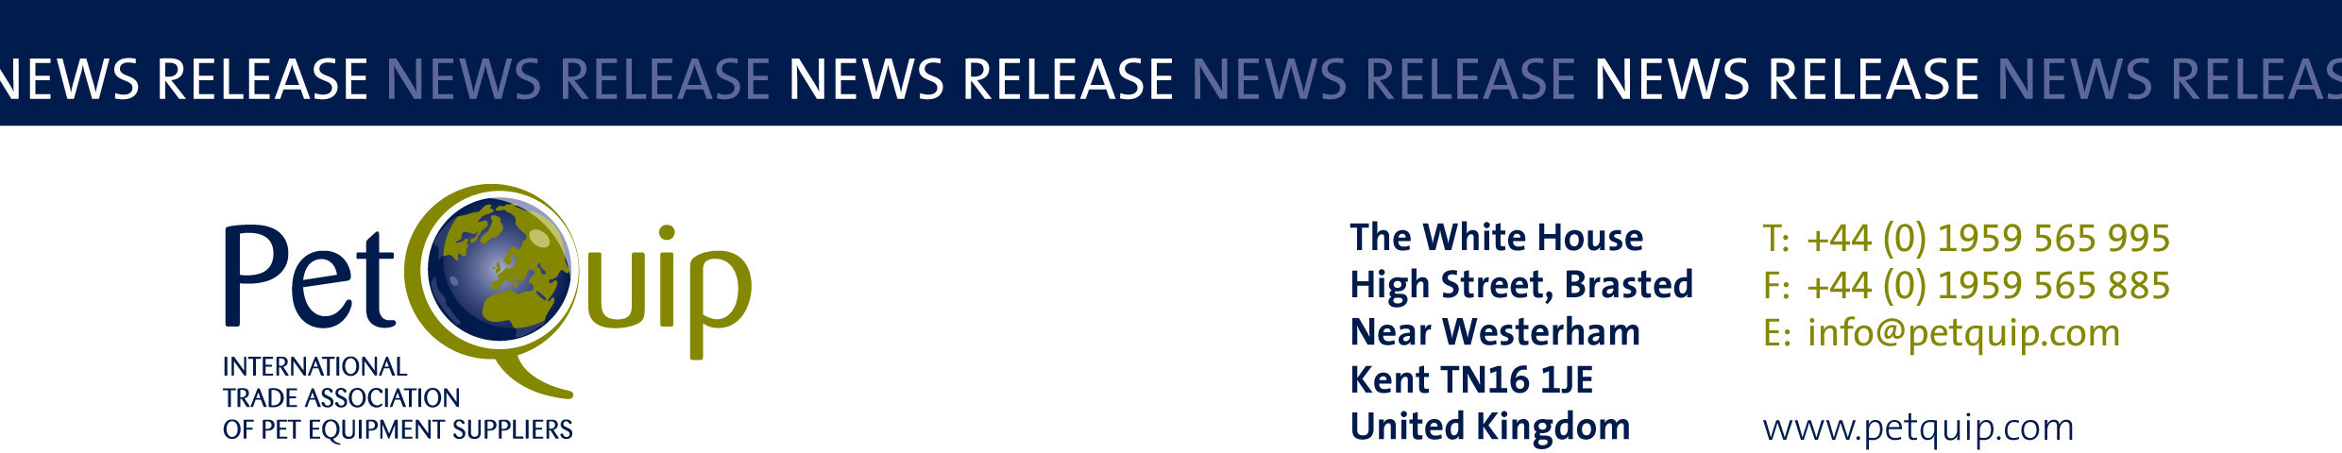

A division of The Federation of Garden and Leisure Manufacturers Limited
Registered in England and Wales No. 706025. Registered Office as above. VAT Registration No. 230906018

FOR IMMEDIATE RELEASE

PetQuip Awards will recognise industry’s outstanding achievements
in an innovative format for 2020

The PetQuip Awards will be celebrating the industry’s achievements in an exciting new format this year.

Because of the Prime Minister’s announcement that conferences are unlikely to be allowed until at least October, the organisers of PATS Telford have taken the decision to cancel the exhibition this year. But PetQuip and the sponsors of the awards, including PATS itself, have agreed to launch an innovative new way to recognise the expertise and achievements of the awards entrants and winners within the pet industry in 2020.

Judging of the PetQuip Awards finalist list is due to be announced in two weeks’ time, ahead of final judging in August.

“To ensure maximum exposure for the winning companies and their products, PetQuip
and the awards headline sponsors – APPA/Global Pet Expo, pbwnews and Natures Menu plus PATS itself – will be supporting a wide-ranging PR campaign for the finalists and award winners throughout the UK and international trade media,” confirms Pat Flynn, Trade Association Manager of PetQuip and organiser of the awards.

All finalists and winners will then benefit from an innovative promotion which will bring their brands and achievements to an influential UK and international audience of buyers.

“We are sad not to be able to meet all our awards finalists and winners in person as usual this year at PATS during our awards event and party: but we have arranged to celebrate the achievements of our entrants in an innovative way which will benefit every participant – a positive benefit in a year when our industry has been facing unprecedented challenges,” said PetQuip Director General Amanda Sizer Barrett.

The PetQuip Awards were due to be announced at its annual presentation evening following the first day of PATS Telford on Sunday, 27th September 2020. But with the decision to cancel the UK’s leading pet industry show because of uncertainty surrounding the re-opening of exhibition centres, the association has focussed instead on an innovative way to celebrate the industry’s achievements – more details will be announced when the 2020 PetQuip awards finalists are announced.

Please contact PetQuip if you would like to benefit from membership of the association or require any further advice and assistance on:
Email: info@petquip.com
Websites: www.petquip.com

For further press information contact:
Neil Pope
PetQuip PR Consultant
Tel: 07595 442601
Email: press@petquip.com

This announcement has been issued by Neil Pope PR Consultant on behalf of The Federation of Garden & Leisure Manufacturers Limited from information provided by the Federation or from organisations associated with the Federation’s initiatives. Reasonable steps have been taken to ensure that the information it contains provided is accurate. However, Neil Pope PR Consultant assumes no responsibility for information contained within the document and disclaims all liability in respect of such information. Neil Pope PR Consultant shall not be held liable for any losses suffered as a result of issuing this information to the press or its use within the media.

