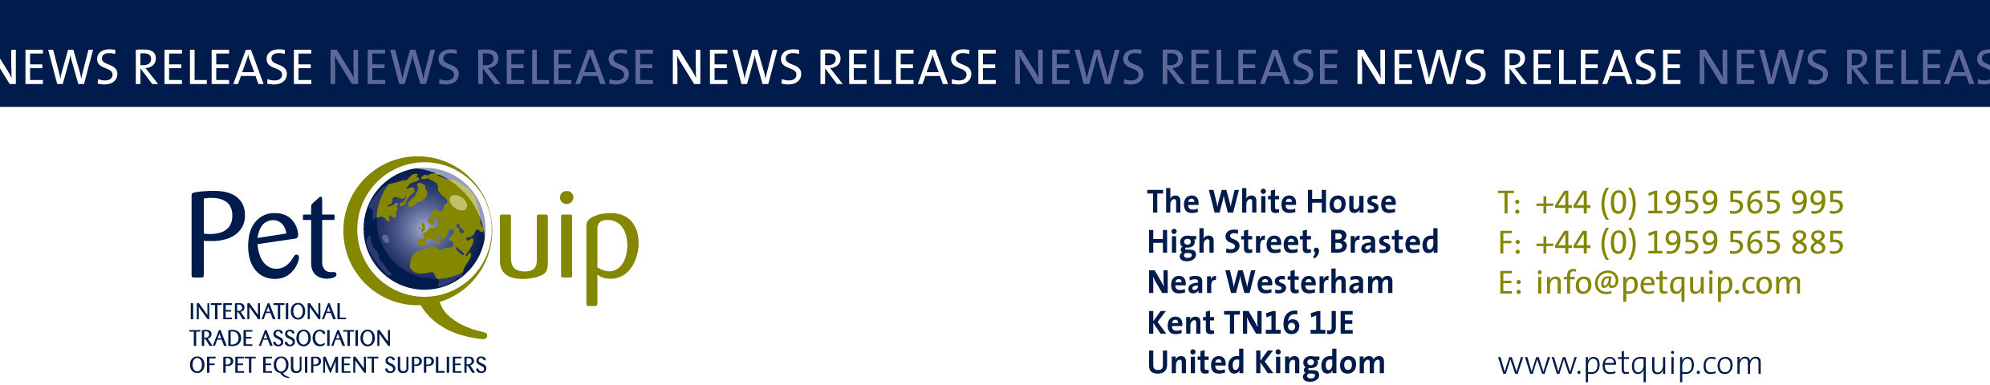

FOR IMMEDIATE RELEASE: 9 June 2023

Get your entries ready for the PetQuip Awards!

Pet product suppliers and retailers who haven’t already entered this year’s PetQuip Awards are being urged by the organisers to start preparing their entries, with the deadline of Friday 30 June fast approaching.

Bringing suppliers, buyers and retailers together, these prestigious awards are the annual industry celebration of product innovation, business success and individual achievement. With nine categories, there is an opportunity for every company to take part.

Running alongside PATS Telford, the awards will take place on Sunday 1 October 2023.

The awards are free to enter. Entrants should complete and return the entry form and send with their full entry, in conjunction with the awards’ guidelines and Terms and Conditions.

Judging will take place in early autumn, with finalists’ names announced shortly afterwards.

The award categories are:

- Supplier of the Year
- Business Service of the Year
- New Starter Award
- Celebrating Green and Organic
- Product of the Year – three categories:
Accessories/Technical; Food/Treats; Healthcare/Animal Grooming
- International Retailer, Wholesaler/Distributor of the Year
- The Theresa Swann Exporter of the Year Award
- UK Retailer of the Year
- Lifetime Achievement Award

The PetQuip Awards include a drinks reception, sit-down dinner and the awards ceremony, followed by a bar, networking and entertainment. It is the annual opportunity for the whole trade to celebrate, mix with colleagues and relax after the first day of the PATS exhibition.

For more information on entering or getting involved as a sponsor visit the PetQuip website or contact the PetQuip team at info@petquip.com.

For further press information contact:
Susan Fairley
Trade Federation Manager
Email: susan@petquip.com

A division of The Federation of Garden and Leisure Manufacturers Limited
Registered in England and Wales No. 706025. Registered Office as above. VAT Registration No. 230906018

