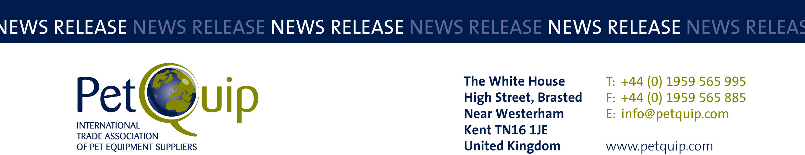

PRESS RELEASE:
A division of The Federation of Garden and Leisure Manufacturers Limited
Registered in England and Wales No. 706025. Registered Office as above. VAT Registration No. 230906018

16 May 2024

UK companies report brisk business on PetQuip pavilion at Interzoo

The association hosted 47 UK exhibitors at the world’s leading trade fair for the pet industry.

Innovation was on display last week at Interzoo, 7-10 May in Nuremberg as the UK pavilion showcased the buoyant UK pet care market. A huge variety of new products were on show: from nutritious, natural food and treats, to healthcare, bedding, packaging, accessories, chicken coops and toys.

With the UK market trending towards natural, premium products and a growth in the population of smaller pets, the line-up of UK companies reflected this imaginative market, with products for dogs, cats, reptiles, guinea pigs and birds among the pets represented.

“The show has been amazing! We’ve seen high level distributors and retailers from all over the world. We’ve got more than 150 leads. It’s probably the best show we’ve ever done,” reported Lewis Ames, Managing Director, Buddycare.

First timer MiAlgae was delighted: “We are new to the pet food market, so being at Interzoo means we’ve had some great conversations directly with people who are looking for a plant based, sustainable marine Omega 3 ingredient. It’s been a great show for us,” commented Ella Robbins, Marcomms Marketing and Communications Manager, MiAlgae.

Packaging supplier Law Print & Packaging Management welcomed the opportunity the event gave the firm to deepen relationships and connections. Carole Bayne, Managing Director explained: “Interzoo is a great platform to develop, partner with and discuss new projects. The quality of visitors we have seen here has been high. Customers have come to us with projects, come here with intention and come here wanting to find a partner.”

PetQuip was honoured by the presentation of a special Interzoo Exhibitor Award at the opening ceremony on the evening before the show opened. The British pavilion was the first national joint pavilion at Interzoo in 1964, the dawn of the exhibition’s international element and its growth. There are now 15 international pavilions at the event.

Amanda Sizer Barrett MBE, Director General of PetQuip accepted the award on behalf of the association, its members and the UK exhibitors:

“We are truly honoured to have been presented with this special award. Over the years, our UK companies have enjoyed very fruitful participations at Interzoo, which has supported their development and has been an important catalyst for their growth into international export markets.”

The PetQuip association will be organising and supporting a UK exhibitor group at the next Interzoo, which will take place from 12 to 15 May 2026.

For details of PetQuip membership, please e-mail info@petquip.com or visit www.petquip.com

For further press information contact:
Amanda Sizer Barrett MBE, Director General. Email: amanda@petquip.com

This announcement has been issued by The Federation of Garden & Leisure Manufacturers Limited from information provided by PetQuip or from organisations associated with the association’s initiatives. Reasonable steps have been taken to ensure that the information it contains provided is accurate. However, the Federation, PetQuip and its member companies assume no responsibility for information contained within the document and disclaim all liability in respect of such information and shall not be held liable for any losses suffered as a result of issuing this information to the press or its use within the media.

