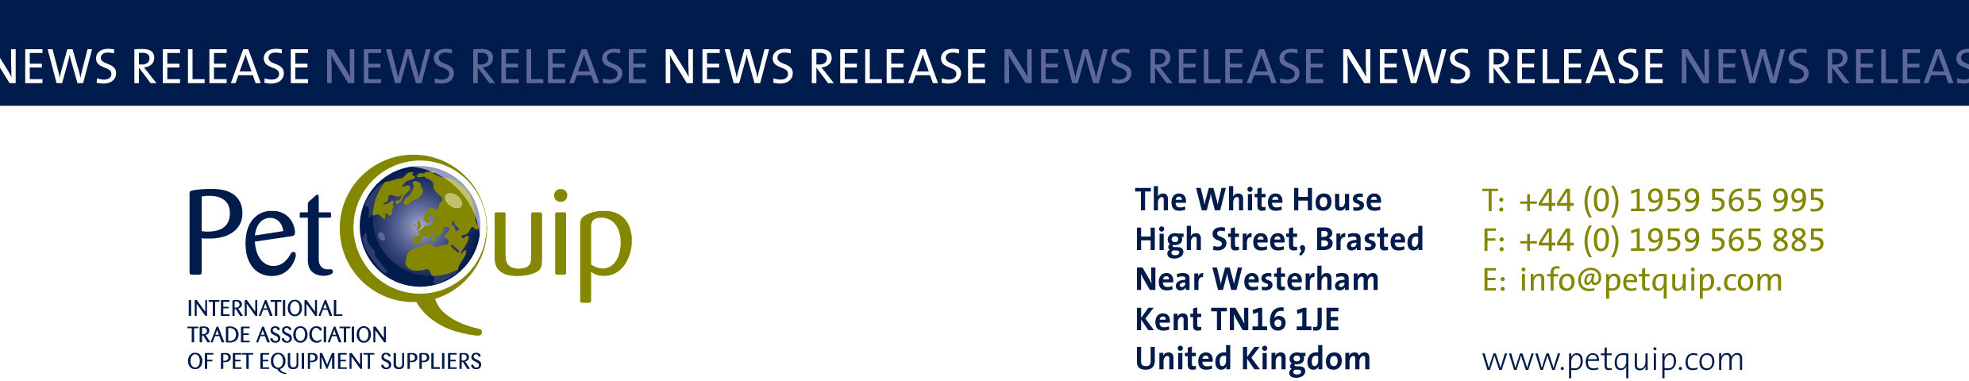

PRESS RELEASE: 27 October 2023
A division of The Federation of Garden and Leisure Manufacturers Limited
Registered in England and Wales No. 706025. Registered Office as above. VAT Registration No. 230906018

Record-breaking UK exhibitor group lines up for Interzoo 2024

PetQuip has announced a strong presence by the UK pet industry at Interzoo, which takes place on 7-10 May 2024 in Nuremburg, with the UK pavilion on course to be the biggest British group ever at the event.

An impressive 34 companies have already confirmed, including Lily’s Kitchen, Canagan, Petlife International, Wildlife World, Buddycare, Bronte Glen, Pet Rebellion, The Barking Bakery and Law Print & Packaging Management.

With exhibitor location at the show of paramount importance, the UK exhibitor group’s position at the front of hall 9 is directly accessible from one of only two entrances to the show and the New Product Showcase adjacent to hall 9 is a hotspot for all visitors to the show.

“We have negotiated a prime position for the UK pavilion and we are well on track to fill the space which we have reserved,” reported Emma Brazier, PetQuip’s Event Manager. “With 80% of the space already allocated, we urge British suppliers who wish to exhibit with us to contact us as soon as possible”.

Interzoo is the world’s leading trade fair for the pet industry, attracting 28,000 trade visitors from 129 countries and over 1,300 exhibitors from 59 countries, meaning that the event is a true international meeting place.

The British group represents the diversity, innovation and vibrancy of the UK pet care sector, which will provide a natural draw for the thousands of retailers, distributors, wholesalers and agents who attend this biennial event.

PetQuip has been organising the UK exhibitor group for many years, providing invaluable logistical support, international promotion, market research and sales leads before, during and after the show.

Key suppliers renew their stand presence at each edition:

“Exhibiting at Interzoo has been invaluable for us over the years. The event has given us the opportunity to promote our products to an international audience, and to meet both distributors and retailers from across the globe. Our export business has grown exponentially as a result of our participation at the show,” confirmed James Hancock, Director, Petlife International.

The PetQuip exhibitor package offers suppliers the opportunity to be part of a fully designed, British themed pavilion, with expert advice and support from the association’s experienced events team, a strong marketing and PR campaign and practical support from the PetQuip team onsite.

The UK PetQuip group will be in Hall 9 stand 9-502a.

For more information on exhibiting, please contact emma@petquip.com

For more information on Interzoo, visit https://www.interzoo.com/en

For details of PetQuip membership, please email info@petquip.com or visit www.petquip.com
For further press information contact:
Amanda Sizer Barrett MBE, Director General. Email: amanda@petquip.com

This announcement has been issued by The Federation of Garden & Leisure Manufacturers Limited from information provided by PetQuip or from organisations associated with the association’s initiatives. Reasonable steps have been taken to ensure that the information it contains provided is accurate. However, the Federation, PetQuip and its member companies assume no responsibility for information contained within the document and disclaim all liability in respect of such information and shall not be held liable for any losses suffered as a result of issuing this information to the press or its use within the media.

