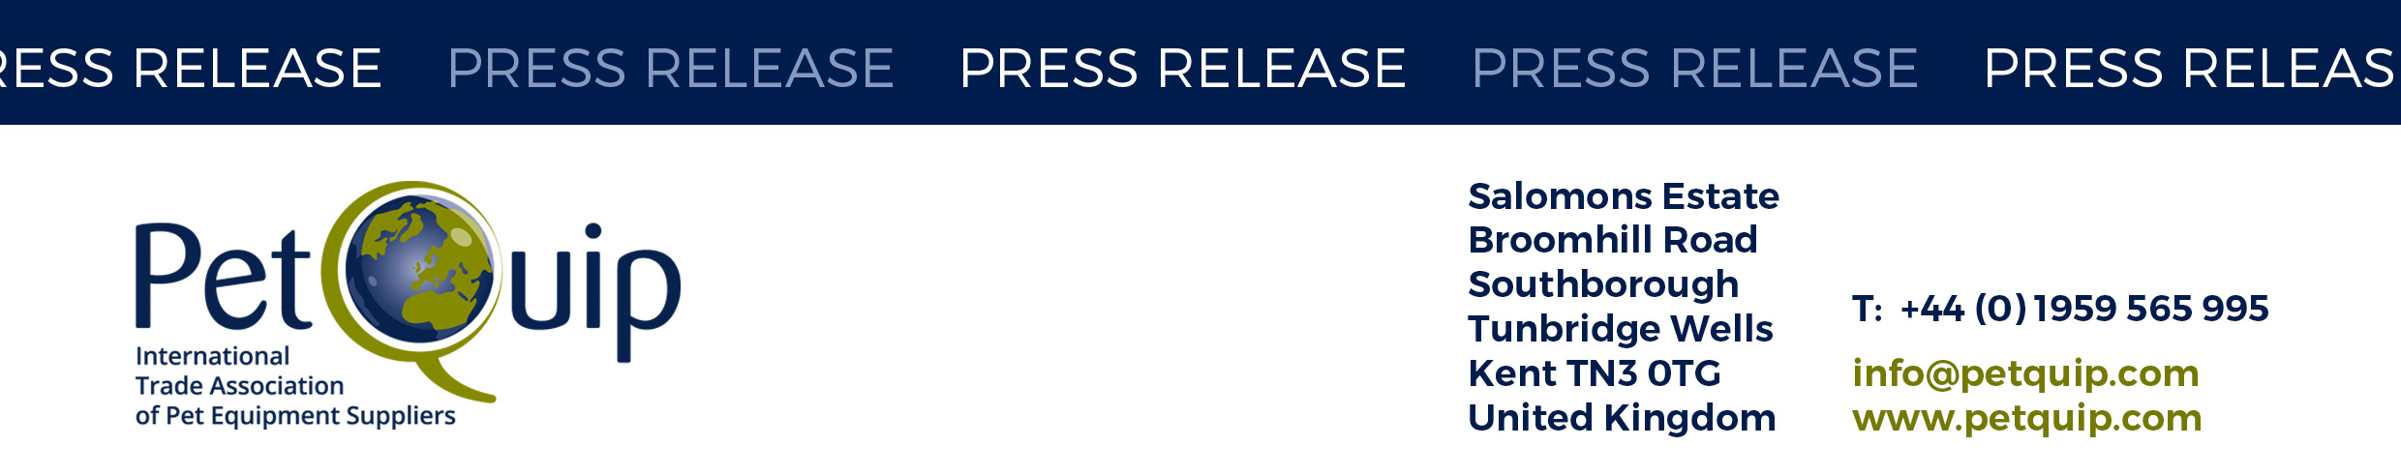

A division of The Federation of Garden and Leisure Manufacturers Limited

Registered in England and Wales No. 706025. Registered Office as above. VAT Registration No. 230906018

**PRESS RELEASE: 8 April 2025**

**PetQuip to host British group at Pet Fair South East Asia**

*Following a successful debut at the event in 2024, the trade association has announced that they will host a UK group at this year’s event, taking place from 29 to 31 October in Bangkok.*

British pet products are highly regarded in South East Asia, particularly in more affluent markets and among pet owners seeking high-quality, health-focused, and premium products.

Pet Fair South East Asia originated four years ago as a virtual event and has grown into an industry experience platform. In 2024 the event hosted over 400 exhibitors from 32 countries and 10,000 trade visitors from more than 80 countries.

Pet Fair South East Asia promises a dynamic and welcoming environment for the UK group, with a central, prime location along the main aisle.

Emma Brazier, Event Manager for PetQuip commented:

“Pet Fair South East Asia offers British companies a valuable opportunity to gain access to a rapidly expanding and diverse market. With growing demand for premium pet products and a strong appreciation of quality, this event provides a platform to showcase products, forge partnerships, and gather insights that will help expand a British brand’s presence in South East Asia. The fair serves as an ideal launch pad for entering or growing within this increasingly lucrative market.”

PetQuip is offering pre-show and on-site support, with fully designed stands, ready for companies to simply turn up and display their products.

Additionally, a series of scheduled press releases and a preview will promote the British group to key buyers and international media.

In 2024, the British group, organised by PetQuip, made an incredibly successful debut, with five exhibitors: Scruffs, James & Steel, Pets Choice, Huntland Pet Food and Animology.

Chris Keightley from Pets Choice reflected: “The reception we received for our products at Pet Fair South East Asia far exceeded our expectations. It was clear that South East Asia values the innovation and quality that come with British products and we received a warm welcome. We have already seen strong demand for our range across several countries as a direct result of our participation".

Further details on exhibiting can be found here.

Companies wishing to enquire about space should contact [emma@petquip.com](mailto:emma@petquip.com)

For details of PetQuip membership, please e-mail [info@petquip.com](mailto:info@petquip.com) or visit [www.petquip.com](http://www.petquip.com)

**For further press information contact:**

Susan Fairley Trade Federation Manager Email: [susan@petquip.com](mailto:susan@petquip.com)

This announcement has been issued by The Federation of Garden & Leisure Manufacturers Limited from information provided by PetQuip or from organisations associated with the association’s initiatives. Reasonable steps have been taken to ensure that the information it contains provided is accurate. However, the Federation, PetQuip and its member companies assume no responsibility for information contained within the document and disclaim all liability in respect of such information and shall not be held liable for any losses suffered as a result of issuing this information to the press or its use within the media.