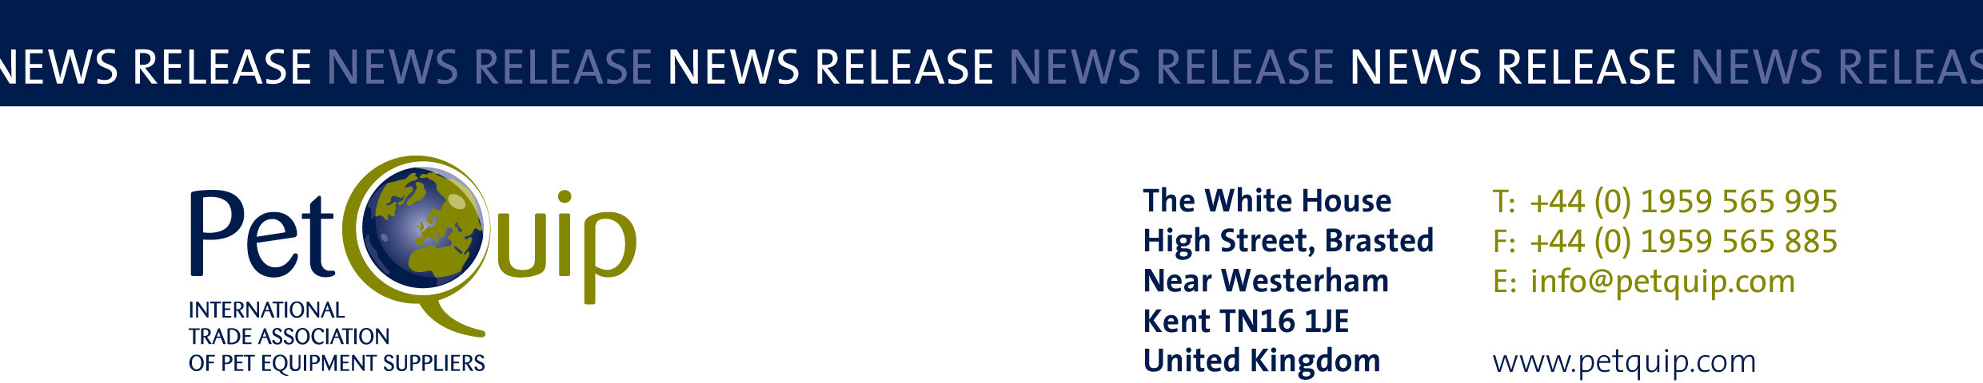

PRESS RELEASE: 4 April 2023
A division of The Federation of Garden and Leisure Manufacturers Limited
Registered in England and Wales No. 706025. Registered Office as above. VAT Registration No. 230906018

PetQuip organises new exhibitor pavilion and attractive stand support package for UK suppliers at SuperZoo 2023

Sign up to take part in this new international sales opportunity targeting the $123 billion-plus US pet industry

The US exhibition SuperZoo on 16-18 August 2023 in Las Vegas is the largest North American trade show for the pet care sector and draws international buyers of pet supplies from the USA, Canada and around the world.

It attracts the key industry players and all who visit are ‘10,000 of the most qualified pet industry retailers, buyers and decision-makers’ – from retailers, the large pet shop chains and pet superstores, supermarkets and mass merchandisers, speciality buyers and e-tailers and key distributors and wholesalers.

During the pandemic SuperZoo organisers utilised the time to vet and re-qualify all past attendees resulting in the most up-to-date qualified attendees for 2022 and future editions.

SuperZoo 2022 welcomed more than 16,000 pet professionals, representing over 25 countries and all 50 States, to engage in new product introductions, expert-led education sessions and peer-to-peer networking events. The 331,500 square foot show floor featured more than 1,000 exhibitors from every pet product category and 900+ products made their debut in SuperZoo’s sold-out New Product Showcase.

SuperZoo continues to be the industry’s go-to trade show for the pet retail community, making it THE event to showcase your products to the US $123.6 billion industry! According to the 2021/2022 National Pet Owners Survey, 70% of US households own a pet; equating to just under 90.5 million homes with pets.

Every UK exhibitor will be supported with a schedule of press releases before, during and after the show, to publicise the goods and services of the British group participants. The PetQuip team will be sending out a preview to named buyers in advance of the show to generate advance publicity for the group, plus providing other marketing tools to promote your presence.

Every exhibitor will also benefit from help with freight, travel & accommodation and other logistics from PetQuip’s dedicated event organisers; plus advice and information about how to prepare for and how to maximise your presence at the show.

During the exhibition, the PetQuip team will be on hand on the association’s industry information stand, promoting the group and directing visiting buyers to your stands.

PetQuip’s British-branded and themed exhibitor pavilion area will be located by the New Product Showcase area of the show floor. The comprehensive stand package for each 10’ x 10’ booth will include:

- Booth carpeting
- 8ft stretch custom printed graphic panel back wall (partial low walls of 3ft high drape between booths for a more open feel)
- One 90cm wide x 90cm high podium with stretch custom printed logo and Britain branding covering and one stool
- Daily booth cleaning
- Company identification sign
- The PetQuip team will assist with ordering any additional items you might require

To find out more about this exciting new opportunity to showcase your products in the US and to book your booth at SuperZoo 2023, contact Emma Brazier on 01959 565 995 or email emma@petquip.com.

For details of PetQuip membership:
Please e-mail info@petquip.com or visit www.petquip.com

For further press information contact:
Amanda Sizer Barrett MBE, Director General. Email: amanda@petquip.com

This announcement has been issued by The Federation of Garden & Leisure Manufacturers Limited from information provided by PetQuip or from organisations associated with the association’s initiatives. Reasonable steps have been taken to ensure that the information it contains provided is accurate. However, the Federation, PetQuip and its member companies assume no responsibility for information contained within the document and disclaim all liability in respect of such information and shall not be held liable for any losses suffered as a result of issuing this information to the press or its use within the media.

