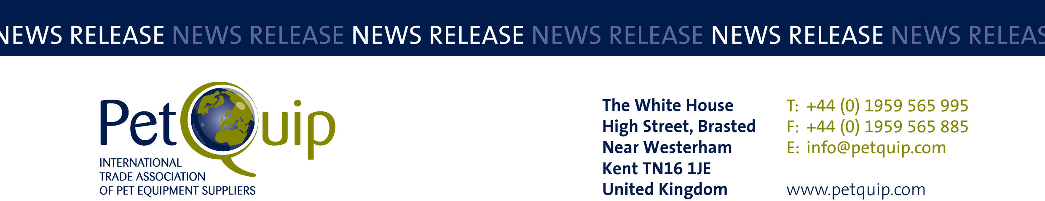

A division of The Federation of Garden and Leisure Manufacturers Limited
Registered in England and Wales No. 706025. Registered Office as above. VAT Registration No. 230906018

FOR IMMEDIATE RELEASE 18 June 2020

Now's the time to enter the PetQuip Awards

Pet product suppliers and retailers who haven’t already entered this year’s PetQuip Awards are urged to submit their entries with the deadline of 30 June 2020 fast approaching.

Judging will take place in August and the winners will be announced at a special ‘Oscar-style’ event during PATS Telford on 27 September 2020.

The PetQuip Awards recognise and reward companies for outstanding performance, and success in this year’s event would provide a welcome morale boost for pet product teams who have been dealing with unique challenges following the outbreak of COVID-19.

Now in their eighth year, the PetQuip awards have consistently delivered professional recognition of the pet industry’s successes and welcome promotion for the short-listed and winning products and brands, celebrated at an enjoyable and lively networking event for the whole industry.

One of the most successful winners in PetQuip Awards history is innovative company HOWND, which has received an impressive four gold awards.

HOWND first did the ‘double’ in 2017 when it was awarded Marketing Project of the Year for its ‘Bring Your Dog to Work Day’ campaign, and Pet Product of the Year (Accessories) for its All Seasons Natural Skin, Nose and Paw Balm.

A year later HOWND repeated its success by retaining the Marketing Project of the Year crown and picking up a second gold for Pet Product of the Year (Food/Treats) with Hemp Wellness Treats.

Jo Amit, co-founder of HOWND, explains how winning multiple PetQuip Awards has increased business for the company. She said: “It’s a great boost to morale to win and to see our peers in the industry so genuinely happy for us when our name was announced at the awards dinner. Who isn’t grateful for a big pat on the back now and again?

“Even the smallest of suppliers should enter. I recommend submitting your entry with the same passion you infused in your product or campaign. Honesty and integrity are key. Just tell your story.”

And Jo recommends booking places for your company’s team at the PetQuip Awards presentation evening and party: “It’s a fun and relaxed night out after a long day at PATS Telford. You don’t often get the chance to unwind with your colleagues in the industry and the atmosphere is lovely.”

Arlene Miller of UK retailer Henry & Co won a silver award in 2019 and confirms: “Thanks to PetQuip, I met a lot of amazing people who gave me so much advice and support.”

The categories for this year’s PetQuip Awards are:
• Marketing Project of the Year
• Exporter of the Year
• Product of the Year (three categories):
- Accessories/Technical
- Food/Treats
- Healthcare/Animal Grooming
• Supplier of the Year
• International Pet Retailer/Distributor of the Year
• UK Pet Retailer of the Year
• Lifetime Achievement

To enter your company in these prestigious awards, visit www.petquip.com/awards to download an entry form or email info@petquip.com if you need further guidance regarding entering the awards.

Please contact PetQuip if you would like to benefit from membership of the association or require any further advice and assistance on:
Email: info@petquip.com
Websites: www.petquip.com

For further press information contact:
Neil Pope
PetQuip PR Consultant
Tel: 07595 442601
Email: press@petquip.com

This announcement has been issued by Neil Pope PR Consultant on behalf of The Federation of Garden & Leisure Manufacturers Limited from information provided by the Federation or from organisations associated with the Federation’s initiatives. Reasonable steps have been taken to ensure that the information it contains provided is accurate. However, Neil Pope PR Consultant assumes no responsibility for information contained within the document and disclaims all liability in respect of such information. Neil Pope PR Consultant shall not be held liable for any losses suffered as a result of issuing this information to the press or its use within the media.

