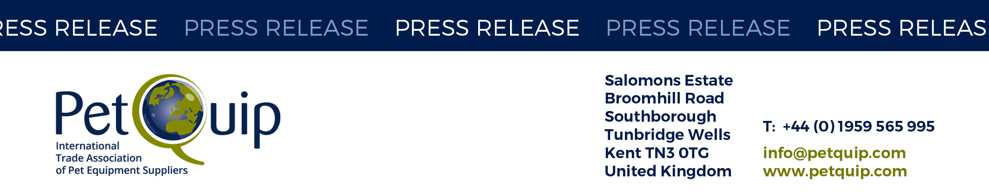

A division of The Federation of Garden and Leisure Manufacturers Limited

Registered in England and Wales No. 706025. Registered Office as above. VAT Registration No. 230906018

**PRESS RELEASE: 18 June 2025**

**Last chance to enter the PetQuip Awards – the industry’s biggest celebration**

The clock is ticking for pet industry professionals to submit their entries for the PetQuip Awards 2025, with only days remaining before the deadline closes. PetQuip is urging businesses across the sector to act now and secure their chance to be recognised at one of the most respected events in the pet industry calendar.

This year’s awards ceremony will take place on Monday 29 September 2025 at the National Conference Centre, located alongside the NEC in Birmingham. Held in association with PATS, the UK’s leading pet and aquatics trade show, the evening promises not only a celebration of business excellence — but also a glitzy, fun-filled party for the entire industry.

**Award categories include:**

* Pet Product of the Year
* Retailer of the Year
* Supplier of the Year
* Exporter of the Year
* Sustainability award
* Marketing campaign of the year
* Rising Star
* Business service of the year
* New starter  
  …and more.

The PetQuip Awards dinner is renowned for its vibrant atmosphere and sense of occasion, and this year promises to be even more. Guests can expect sparkling entertainment, surprisemoments, and a night of celebration with the industry’s finest — all in an exciting new format designed to deliver a true party experience.

“This is more than an awards ceremony — it’s a night the industry looks forward to all year,” commented Joe Denham, PetQuip’s Director General. “With new surprises planned, live entertainment, and a dazzling setting, we’re making sure the 2025 event will be the most memorable yet. For businesses hoping to be in the spotlight, this really is the last chance to enter.”

These are the final days to enter – companies are encouraged not to miss the chance to gain recognition and celebrate in style with the industry’s best.

**Entry Details:**

Entry is £50 per company for unlimited entries. Submit by **Thursday 26 June** via <http://www.petquip.com/uk/awards-enter.htm>

**Dinner tickets:**

Tickets for the awards dinner and presentation are £110+VAT for PetQuip members and £125+VAT for non-members: <http://www.petquip.com/uk/awards-tickets.htm>

PetQuip Awards are sponsored by Leopard Co (headline), Law Print & Packaging, Copdock Mill, Zoomark, PBW News, CIPS, Interzoo, Noble Futures, James & Steel, Buddycare, Petface, Pedigree, PATS and PPM

For details of PetQuip membership, please e-mail [info@petquip.com](mailto:info@petquip.com) or visit [www.petquip.com](http://www.petquip.com)

**For further press information contact:**

Joe Denham Director General Email: [joe@petquip.com](mailto:joe@petquip.com)

This announcement has been issued by The Federation of Garden & Leisure Manufacturers Limited from information provided by PetQuip or from organisations associated with the association’s initiatives. Reasonable steps have been taken to ensure that the information it contains provided is accurate. However, the Federation, PetQuip and its member companies assume no responsibility for information contained within the document and disclaim all liability in respect of such information and shall not be held liable for any losses suffered as a result of issuing this information to the press or its use within the media.