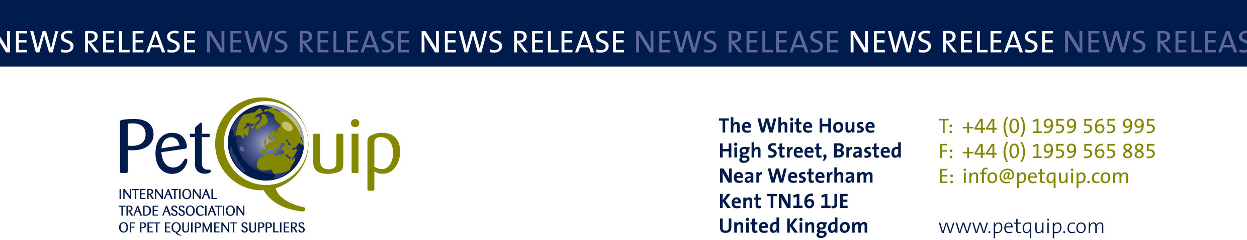

PRESS RELEASE: 2 October 2023
A division of The Federation of Garden and Leisure Manufacturers Limited
Registered in England and Wales No. 706025. Registered Office as above. VAT Registration No. 230906018

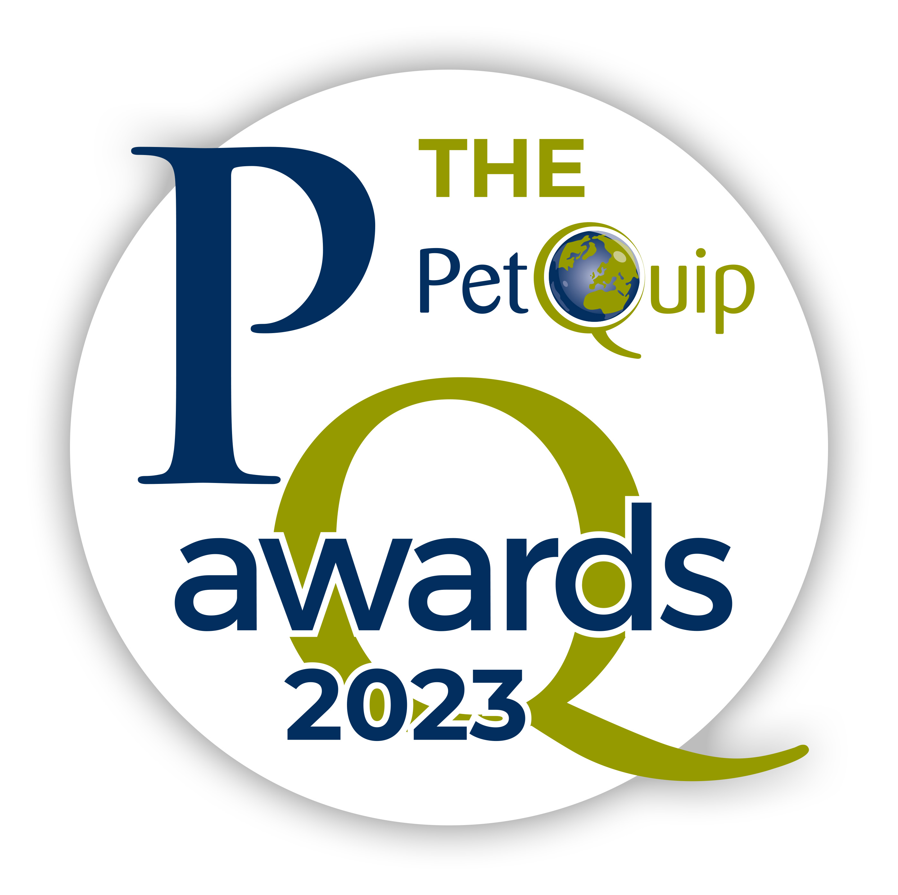

PetQuip Awards shine as the pet industry celebrates
at sell-out event

Last night’s PetQuip Awards hosted a record number of guests as the pet industry convened to recognise excellence and celebrate achievement.
Held alongside and in association with PATS Telford, the PetQuip Awards cover Supplier, Retailer, Product, Export and Lifetime Achievement categories, with Gold, Silver and Highly Commended prizes for most categories.
The event, presented by Susan Fairley, PetQuip Trade Federation Manager, and Amanda Sizer Barrett MBE, Director General of the PetQuip association, included 12 Gold and 10 Silver awards, plus nine Highly Commended awards, Also awarded was a special Lifetime Achievement Award for John Burns MBE, the founder of the UK’s first natural and chemical-free pet food company, Burns Pet Nutrition.
As John accepted his award from Amanda Sizer Barrett, he said “I’m overwhelmed. It’s such an honour to receive this accolade from PetQuip.”
To recognise the innovative companies exhibiting in the PATS Telford New Starter Zone, created in association with PetQuip trade association, the PetQuip Awards introduced a new category for this year, the New Starter Award. With so many creative and innovative entrepreneurs coming through into the pet industry, the competition was tight.

The Gold winner was Trinkety Paws, an accessories range whose hallmark is an array of beautiful colours, designed and made by the owner. The judges praised the business, which really stands out at shows with a lovely product.

Nadine Berger, Director of Trinkety Paws said: “I’m shocked and surprised to have won the New Starter Award. To be recognised in this prestigious way means a lot, and feels like all our hard work has paid off.”
The Silver award went to pet memorial rainbow bridge maker The British Glass Lady and Highly Commended to Oh So Precious, who also create pet memorials.

At the close of the event, Amanda Sizer Barrett commented: “The enjoyment evident on the faces of so many people from the industry at our event has made it all worthwhile. PetQuip is proud to recognise the hard work, innovation and teamwork demonstrated by our industry with these prestigious awards and it was great to celebrate with them at what was a sell-out occasion.
“In addition to seeing so many happy winners, it was really rewarding to witness everyone enjoying the fruits of their labours and the positive networking that took place between suppliers and buyers during the evening.”

WINNERS:

Supplier of the Year - Sponsored by Noble Futures
Gold: joint winners Pedigree Wholesale and We.pet
Silver: joint winners Burgess Pet Care and Pet Trade Innovations
Highly Commended: Brambles Pet and Wildlife

Business Service of the Year – Sponsored by Whistl
Gold: Henry & Co
Silver: Ant Antics
Highly Commended: Pet Trust UK

New Starter Award – Sponsored by Pet Trade Innovations
Gold: Trinkety Paws
Silver: The British Glass Lady
Highly Commended: Oh So Precious

Celebrating Green and Organic – Sponsored by CIPS
Gold: Mr Bug
Silver: Naturaw
Highly Commended: Verm-X

Product of the Year: Technical/Accessories
Gold: Dog First Aid Kit from Poorly Paws
Silver: The modular and portable Dog-G8 Gate from the Dog-G8 Company
Highly Commended: Puppy Starter Kit from DogSpace

Product of the Year: Food/Treats
Gold: Wellness Treats from HOWND
Silver: Vet’s Menu Gravy Topper from Macahl Animal Health
Highly Commended: Nature’s Deli Grain-Free Tasty Paste from Pedigree Wholesale

Product of the Year: Healthcare/Grooming
Gold: TropiClean Essentials Collection from Pedigree Wholesale
Silver: TropiClean Enticers Dental Ball Kit for Dogs from Pedigree Wholesale
Highly Commended: Gizzls Gut Support from Gizzls

International Retailer/Wholesaler/Distributor of the Year – Sponsored by PATS Telford
Gold: Tom & Co, Belgium

UK Retailer of the Year – Sponsored by PATS Telford
Gold: Discount Feeds
Silver: Henry & Co
Highly Commended: Cocopup London

The Theresa Swann Exporter of the Year Award – Sponsored by Group55
Gold: Mutneys Professional Pet Care
Silver: HOWND
Highly Commended: Macahl Animal Health

Lifetime Achievement Award
John Burns MBE, Burns Pet Nutrition

Comments from some of the winners:
Conal Cunningham, Managing Director of Mr Bug
“Winning the Celebrating Green and Organic Award is marvellous and recognition for everything we’re trying to do with this brand.”

Alex and Gabriella Surace, owners of Poorly Paws
“Wow! We couldn’t believe it when the name of our business was announced as the winner of the Product of the Year Award for accessories and tech. It feels like all the hard work has paid off. We’re extremely grateful.”

Jo Amit, Product Director of HOWND
“The Product of the Year food and treats was such a big category that we really didn’t expect to win, so it was an unexpected and welcome surprise. Having won several PetQuip Awards in the past, we know the importance of these accolades because they act as a springboard for the product. To win again is fantastic.”

Dan Vander of We.Pet
“We were really surprised and delighted. We are still a fairly new kid on the block so we were very flattered. It’s something to shout about and will hopefully give us increased recognition in the trade. Everyone likes a bit of kudos!”

Please contact PetQuip if you would like to benefit from membership of the association or require any further advice and assistance on:
Email: info@petquip.com Website: www.petquip.com

For further press information contact:
Amanda Sizer Barrett MBE, Director General. Email: amanda@petquip.com

This announcement has been issued by The Federation of Garden & Leisure Manufacturers Limited from information provided by PetQuip or from organisations associated with the association’s initiatives. Reasonable steps have been taken to ensure that the information it contains provided is accurate. However, the Federation, PetQuip and its member companies assume no responsibility for information contained within the document and disclaim all liability in respect of such information and shall not be held liable for any losses suffered as a result of issuing this information to the press or its use within the media.

