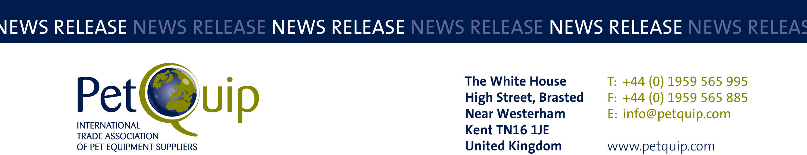

PRESS RELEASE: 23 November 2023
A division of The Federation of Garden and Leisure Manufacturers Limited
Registered in England and Wales No. 706025. Registered Office as above. VAT Registration No. 230906018

A great reward at the PetQuip Awards Dinner

Noble Futures introduces Nature’s SAFE to the pet trade dinner at the PetQuip Awards on Sunday 1 October.

Hosted alongside PATS Telford, the PetQuip Awards are an annual opportunity to recognise innovative brands across the UK’s vibrant pet industry. This year, for the first time ever, the PetQuip Awards hosted a chosen charity at the event. Nature’s SAFE, one of Europe’s first charitable living biobanks working to Save Animals From Extinction through cell & tissue preservation for future regeneration, was the guest of honour.

Tullis Matson, Chair and one of the founders of this extraordinary charity, joined the evening to share a glimpse into the inspiring work the charity is doing to protect threatened animal species. Through a brilliant prize draw on the night, guests raised over £2,000 for this extraordinary work.

Tullis Matson said about the event. “We are so grateful to PetQuip and Noble Futures for giving us this fantastic opportunity to share the work we are involved in with a new audience. Without Nature’s SAFE, for many species already so near the brink of extinction, there will be no return. With Nature’s SAFE and other biobanking partners, there is optimism and The PetQuip Awards gave us a platform to share this knowledge so that the industry could hear that there is a plan for the future.”

It was also the Noble Futures team’s very first PetQuip Awards, where they acted as sponsor for both Nature’s SAFE and the prestigious Supplier of the Year award.

Tony Noble, Managing Director and Founder of Noble Futures commented: "All of us at Noble Futures are so inspired by the work Nature's SAFE does that we simply had to get involved and help in any way we can. Working within the Pet and Animal Health space, Noble Futures already partners with many of PetQuip's members, so sponsoring at the awards felt right and so did the marriage of Nature's SAFE as sponsored charity. It was a wonderful evening, celebrating the best in the Pet industry and a great way to shine a light on our charity partner, Nature's SAFE, to a room full of people passionate about animals and nature."

Susan Fairley, Trade Federation Manager for the PetQuip Awards, commented: “This year was the first time we have worked with a charity partner as part of our awards evening. The presentation of the charity’s work, plus the amazing prizes donated for the draw, added both moving and entertaining elements to the awards evening, contributing to its undoubted success. Our guests were moved and inspired by the charity’s work, demonstrated by the audience’s reaction and the incredible total raised on the night.”

For more details on the PetQuip Awards 2024, please contact Susan Fairley, Trade Federation Manager.

Notes to editors
Nature’s SAFE is a registered charity No 1192876.
Tullis Matson FRAgS, HonDTech, DL, Founder and Chair of Nature’s SAFE. Tel: 07801 592111 / 07743780217. Email: tullis@natures-safe.com
Debbie Rolmanis, Trustee and Communications Chair of Nature’s SAFE.
Email: debbie@capitalagri.global

For details of PetQuip membership, please e-mail info@petquip.com or visit www.petquip.com

For further press information contact:
Amanda Sizer Barrett MBE, Director General. Email: amanda@petquip.com

This announcement has been issued by The Federation of Garden & Leisure Manufacturers Limited from information provided by PetQuip or from organisations associated with the association’s initiatives. Reasonable steps have been taken to ensure that the information it contains provided is accurate. However, the Federation, PetQuip and its member companies assume no responsibility for information contained within the document and disclaim all liability in respect of such information and shall not be held liable for any losses suffered as a result of issuing this information to the press or its use within the media.

