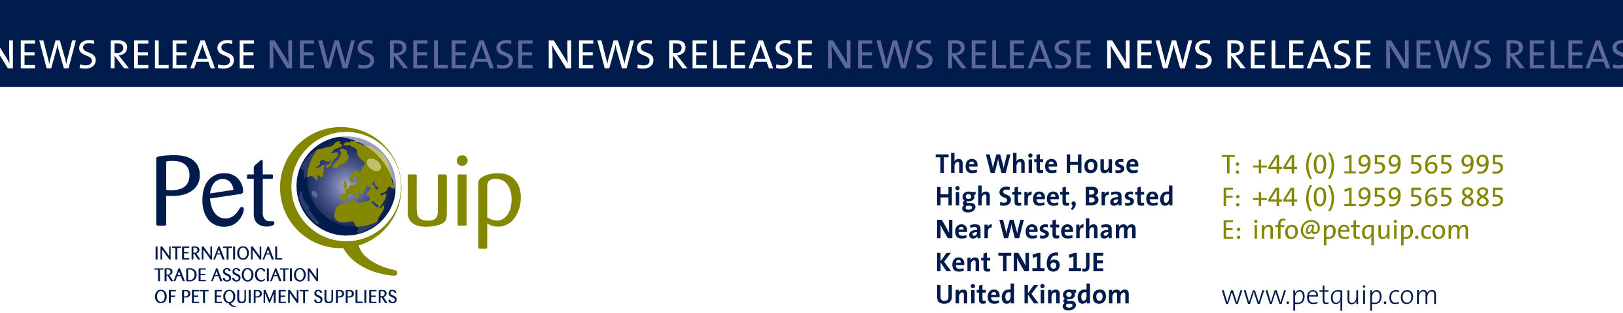

PRESS RELEASE: 15 February 2023
A division of The Federation of Garden and Leisure Manufacturers Limited
Registered in England and Wales No. 706025. Registered Office as above. VAT Registration No. 230906018

Join leading British firms flying the flag at Zoomark 2023
in the PetQuip exhibitor group

PetQuip is running the British Pavilion at Zoomark in Bologna, Italy on 15-17 May, supporting businesses in their continued export drives.

The UK exhibitor group also features the PetQuip industry information stand and meeting point, where the multi-lingual PetQuip team will be promoting British pet product innovations and suppliers and meeting international buyers on the stand.

The team will be ensuring that Great Britain’s place as a professional nation of top class pet product suppliers is recognised by international pet product retailers and distributors.

If you haven’t yet decided to take part in the UK pavilion, there is still time to be part of the exhibitor group: we have secured space to accommodate those of you who haven’t been able to plan your exhibition presence until now.

The new areas will be snapped up quickly so do make sure you get in touch if you would like to showcase your products to attendees at one of the best international exhibitions in the show calendar.

Setting aside the numerous networking opportunities in the restaurants of Bologna once the show has ended each day, the exhibition itself is a bustling and energetic event that has grown in size from its early beginnings in two halls.

Zoomark is now a popular destination for visitors from outside Italy and the EU and the Italian market alone has 62 million pets and 5000 independent pet stores.

Our exhibitors to date include industry stalwarts Burns Pet Nutrition, Canagan, Vitalin, Hugo Kamishi, CSI Urine, Kompact 9, Eden Holistic Pet foods, Animology, PATS and Aqua, James & Steel Ltd / Canny Collar, JG Pears, McAdams Free Range Pet Foods, Pets Choice, Petlife International Ltd, Poochiful, ProFleece - Simply2 Pet Products, Tribal Pet Foods, Symply, We.pet and Yora Pet Foods for the Planet.

Please contact Emma Brazier on emma@petquip.com or Pat Flynn on pat@petquip.com for more details about the show and the comprehensive range of logistical and marketing support you receive when you exhibit with PetQuip to support your show presence.

For details of all the business advantages of PetQuip membership, please email info@petquip.com or visit www.petquip.com

For further press information contact:
Amanda Sizer Barrett MBE, Director General. Email: amanda@petquip.com

This announcement has been issued by The Federation of Garden & Leisure Manufacturers Limited from information provided by PetQuip or from organisations associated with the association’s initiatives. Reasonable steps have been taken to ensure that the information it contains provided is accurate. However, the Federation, PetQuip and its member companies assume no responsibility for information contained within the document and disclaim all liability in respect of such information and shall not be held liable for any losses suffered as a result of issuing this information to the press or its use within the media.

