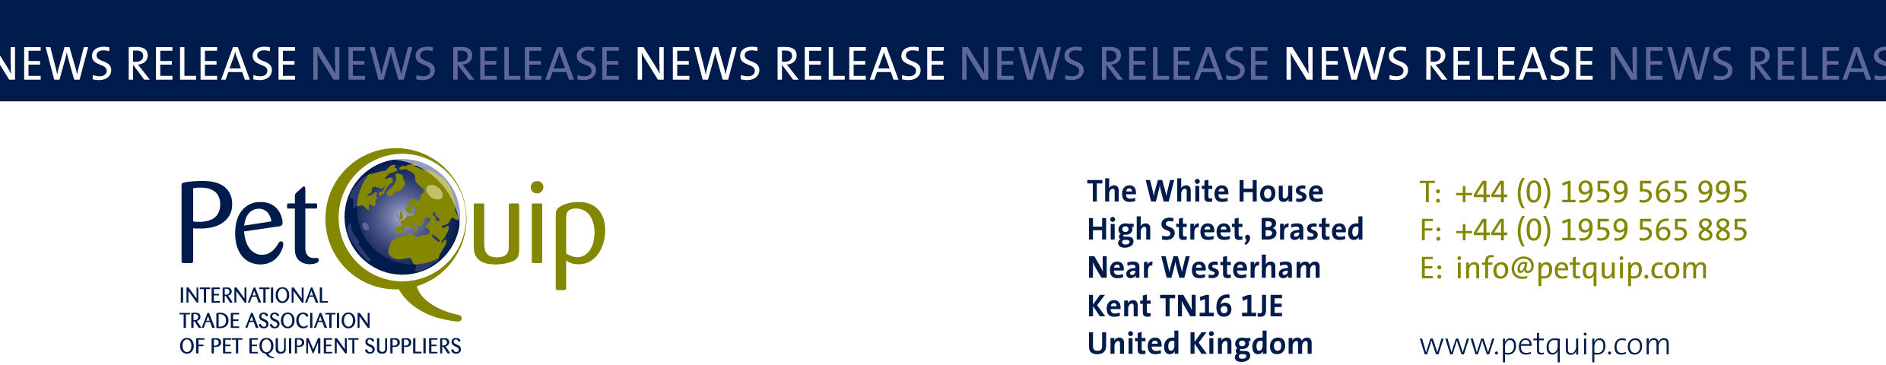

FOR IMMEDIATE RELEASE 16th March 2020
A division of The Federation of Garden and Leisure Manufacturers Limited
Registered in England and Wales No. 706025. Registered Office as above. VAT Registration No. 230906018

PetQuip to support UK pet firms in light of Interzoo postponement

PetQuip has announced that it will update UK pet businesses scheduled to exhibit at Interzoo on developments following the decision to postpone the international trade exhibition.

Interzoo was due to take place on May 19-20 in Nuremburg, Germany, but the organisers have decided to postpone it because of the spread of coronavirus.

“We will stay in regular contact with the Interzoo organisers ahead of their announcement of the new dates for the event,” said Amanda Sizer Barrett, Director General of PetQuip.

“We will continue to monitor the coronavirus situation and will be providing our members and show exhibitors with more updates as and when we hear from the organisers.”

Interzoo organisers have confirmed they expect to announce a new date for the show by the end of March.

“We will be working hard to support our members through these challenging times,” added Amanda.

“PetQuip will shortly be announcing a new package of publicity and support to ensure that all our exhibitors’ brands and product introductions are promoted to buyers during the postponement period.

“Then nearer to the new exhibition dates we will distribute our comprehensive press material to all key international journals, plus send our multi-lingual preview to our exclusive database of international buyers.”

Contact PetQuip if you require further advice and assistance:
Tel: +44 (0) 44 1959 565995
Fax: +44 (0) 1959 565885
Email: info@petquip.com
Website: www.petquip.com

For further press information contact:
Neil Pope (Oskar Media)
PetQuip PR Consultant
Tel: 07595 442601
Email: oskarmedia@btinternet.com

