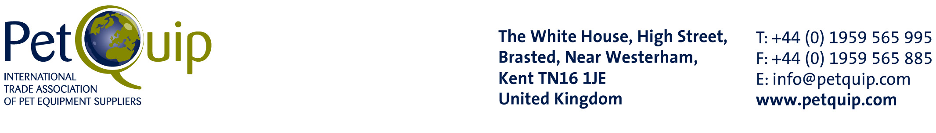

PRESS INFORMATION REQUEST
Interzoo, Nürnberg, 22-25 May, 2008

- Please complete this form by supplying your company details and any news about your business that you would like to appear in the international press and be presented to overseas buyers. Provide as much information as possible and please feel free to attach additional text or expand any rows where necessary.
- Email this form, together with a colour image depicting your product range and your company logo (preferably in jpeg format, at least 300dpi) to neale@petquip.com
 |  |  |  | Tick which name you prefer to publish √
COMPANY NAME:
COMPANY KNOWN AS:
ADDRESS (INCLUDING POST CODE)
COMPANY TEL: | +44 (0) | COMPANY FAX: | +44 (0)
COMPANY EMAIL:
WEBSITE:
STAND NO. AT INTERZOO
NAME OF MAIN EXPORT SALES CONTACT:
ON SITE MOBILE OF MAIN EXPORT SALES CONTACT:

About your company (especially any interesting history, heritage or production techniques etc):

Describe your product range:

Summarise your product range (in no more than 10 words please):

New product launches:

Brief details of any history your company has with the German market, and/or other major markets:

What are your main aims at the show (for example, to find new distributors etc):

If you have agents or distributors whose names should appear in the editorial, please name them:

Any other information that will whet the appetites of the journalists?

Please email this form with a colour image depicting your product range and your company logo (preferably in jpeg format, at least 300dpi) to neale@petquip.com

All releases and features issued on behalf of PetQuip are approved by the association prior to distribution but please note that neither PetQuip nor its appointed consultant take responsibility for the accuracy of individual company or product information supplied by its members.

