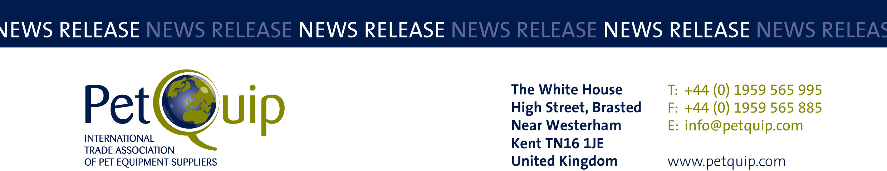

PRESS RELEASE: 23 April 2024
A division of The Federation of Garden and Leisure Manufacturers Limited
Registered in England and Wales No. 706025. Registered Office as above. VAT Registration No. 230906018

PetQuip Awards 2024 Now Open for Entries

PetQuip has announced that entries are now welcome as the association’s prestigious awards are launched.

Reflecting the dynamism of the UK petcare sector, the annual awards recognise and reward the energy, achievement and innovation realised within the pet product trade over the last year.

The winners of the PetQuip awards will be announced at the gala dinner, which takes place on Monday 30 September at Telford International Centre, alongside PATS, the pet and aquatics trade show.

The evening is a chance for networking, celebrating and congratulating success for everyone in the sector. In 2023, over 230 suppliers and retailers learned who the winners were while enjoying a drinks reception, three course meal, refreshments and dancing and music afterwards.

The 15 awards include categories for product, marketing, retailers, suppliers, sustainability and individual achievement.

New categories for this year include rising star, employee of the year and best marketing campaign, with the UK retailer award now being split into independent and multiple retailers.

Entry is free and companies can enter more than one category. Entry is online via the PetQuip website. Entries close on Thursday 27 June, finalists will be announced in August and the awards will be presented at the dinner on Monday 30 September.

“The PetQuip Awards evening is a well-established date in the UK pet industry’s calendar, not only because of the exceptional accolade that winning an award can bring, but also as a lively party for everyone involved in this buoyant and innovative sector.

“Many of the firms who have won awards previously have reported back to us on the value of winning, which shines a spotlight on the company, enhancing their profile and potentially boosting sales”, said organiser Susan Fairley.

Award sponsors confirmed so far include Noble Futures, Pedigree Wholesale, SUPERZOO, Zoomark, PATS, CIPS, Law Print and Packaging, James & Steel, Group55 and Petface.

For more information about sponsorship, please contact Susan Fairley.
For more information about the awards please email info@petquip.com
To enter the awards, visit petquip.com

Award categories
Supplier of the year
Business service of the year
Most promising new starter business
Theresa Swann Exporter of the year – sponsored by Group55
Best product: food/treats
Best product: healthcare/grooming
Best product: accessories/technical
Sustainability award – sponsored by China International Pet Show
UK retailer of the year: multiple
UK retailer of the year: independent
International retailer/distributor of the year
Best marketing campaign
Rising star – sponsored by Noble Futures
Employee of the year
Lifetime achievement

For details of PetQuip membership, please e-mail info@petquip.com or visit www.petquip.com

For further press information contact:
Amanda Sizer Barrett MBE, Director General. Email: amanda@petquip.com

This announcement has been issued by The Federation of Garden & Leisure Manufacturers Limited from information provided by PetQuip or from organisations associated with the association’s initiatives. Reasonable steps have been taken to ensure that the information it contains provided is accurate. However, the Federation, PetQuip and its member companies assume no responsibility for information contained within the document and disclaim all liability in respect of such information and shall not be held liable for any losses suffered as a result of issuing this information to the press or its use within the media.

